# Declaration

I would like to declare that we have successfully completed a three month internship program at Gondar Pepsi-Cola factory. I have stayed from june 23/2017 to july 23/ 2017E.C. This paper includes all requirements of an internship program. I want to assured that this report exactly belongs to us. I have done a project during the internship program and is included as part of this report. I were fully engaged to write this report and also to perform our project. Except I have taken from reference materials all the descriptions, recommendations are our own. Finally, I are intended to tell you this document is a good indicator of how much effort I made to go steps forward in the practical world by integrating it with the theoretical knowledge.

# Acknowledgment

First of all thanks to God for keeping all things to be happened in good manner. I would like thanks to Injibara University for giving this chance to get practical skills & Gondar Pepsi Cola plant for accepting us to get costless knowledge. There are many people around that have supported us all the way through and to make things easier. I tank my advisor Dr. Wedaje .A for visiting and advising us in doing of our project and report. I thanks for managers and employees of Gondar Pepsi Cola Company specially the company supervisor Mr. Nuredin Y. who is supervisor of production for his incredible level of advice, many suggestions and constant support at every step of this report. This report could not finalize without his regular valuable suggestion and encouragement. And, I have a great honor for other employees for their genuine intention to teach us under great motivation. Finally I would like tank Alemneh Belay and his wife who help me to write this report with their own computer and to give comments.

# Executive summery

MOHA soft drink industry S.C is one of the leading competitive companies in Ethiopia which is found in most Ethiopian region. It has many branches. Among them Gondar plant is one of its branch which is found in Amhara region. Currently Gondar Pepsi cola plant manufactures Pepsi and Miranda only. It uses oldest technology, different machines, materials, human skills and methods to manufacture its products qualitatively and quantitatively. This report consists of the brief history and profile of our hosting company including the main raw material used to produce its main products. And also the main customers that use its main products and supplier, consequently its organizational structure and detail work flow of beverages production activities in each section and the overall systems of the organization. The report also describes the current practice and activities that take place in the production Department and other main supportive departments. Finally the main benefit of internship is also included on this report. I have also done our project based on primary waste water treatment and characterization of waste water.

Table of Contents Page

[Declaration i](#_Toc73353491)

[Acknowledgment ii](#_Toc73353492)

[Executive summery iii](#_Toc73353493)

[Symbol and abbreviation iv](#_Toc73353494)

[CHAPTER ONE 1](#_Toc73353495)

[1. Back ground of company 1](#_Toc73353496)

[1.1 introduction 1](#_Toc73353497)

**[1.2 brief history of the company](#_Toc73353498)** [1](#_Toc73353498)

**[1.3 Objectives of the company](#_Toc73353499)** [1](#_Toc73353499)

**[1.3.1 The General objective](#_Toc73353500)** [1](#_Toc73353500)

**[1.3.2 Specific objectives](#_Toc73353501)** [2](#_Toc73353501)

**[1.4 Vision, mission and core values of the company](#_Toc73353502)** [2](#_Toc73353502)

**[1.4.1 Vision of the company](#_Toc73353503)** [2](#_Toc73353503)

**[1.4.2 Mission of the company](#_Toc73353504)** [2](#_Toc73353504)

**[1.4.3 Core values of the company](#_Toc73353505)** [2](#_Toc73353505)

**[1.5 Future Program of the Company](#_Toc73353506)** [2](#_Toc73353506)

**[1.6 Main Products of Gondar Pepsi-Cola Company](#_Toc73353507)** [3](#_Toc73353507)

**[1.7 The Main Customers/End Users of Its Products](#_Toc73353508)** [3](#_Toc73353508)

**[1.8 Organization structure of the company](#_Toc73353509)** [3](#_Toc73353509)

**[1.8.1 Responsibilities of the department](#_Toc73353510)** [4](#_Toc73353510)

[CHAPTER TWO 8](#_Toc73353511)

**[2. The overall internship experience](#_Toc73353512)** [8](#_Toc73353512)

**[2.1 How I Get Into the Gondar Pepsi Cola Company](#_Toc73353513)** [8](#_Toc73353513)

**[2.2 General Process Flow Sheet of Gondar Pepsi-Cola](#_Toc73353514)** [9](#_Toc73353514)

**[2.3 Main Rooms of Gondar Pepsi Cola Plant](#_Toc73353515)** [10](#_Toc73353515)

**[2.3.1 Water Treatment Section](#_Toc73353516)** [10](#_Toc73353516)

**[2.3.2 Boiler Room](#_Toc73353517)** [16](#_Toc73353517)

**[2.3.3 Air Compressor Room](#_Toc73353518)** [17](#_Toc73353518)

**[2.3.4 Syrup Room](#_Toc73353519)** [18](#_Toc73353519)

**[2.3.5 Bottle Washer](#_Toc73353520)** [21](#_Toc73353520)

**[2.2.6 Filling room](#_Toc73353521)** [24](#_Toc73353521)

**[2.3.7 CIP Method](#_Toc73353522)** [27](#_Toc73353522)

**[2.3.8 Quality Control Section](#_Toc73353523)** [28](#_Toc73353523)

[CHAPTER THREE 29](#_Toc73353524)

**[3. Material and energy balance](#_Toc73353525)** [29](#_Toc73353525)

**[3.1 introduction](#_Toc73353526)** [29](#_Toc73353526)

**[3.2 material balance](#_Toc73353527)** [29](#_Toc73353527)

[ENERGY BALANCES 30](#_Toc73353528)

**[3.3 Energy balance](#_Toc73353529)** [35](#_Toc73353529)

[CHAPTER FOUR 36](#_Toc73353530)

**[4. Environmental & socio-economic analysis](#_Toc73353531)** [36](#_Toc73353531)

**[4.1 environmental analysis](#_Toc73353532)** [36](#_Toc73353532)

**[4.2 socio-economic analysis](#_Toc73353533)** [36](#_Toc73353533)

[CHAPTER FIVE 38](#_Toc73353534)

**[5. Case study](#_Toc73353535)** [38](#_Toc73353535)

**[5.1 The challenges faced in the hosting company](#_Toc73353536)** [38](#_Toc73353536)

**[5.2 Characterization of wastewater effluent in gpcp](#_Toc73353537)** [38](#_Toc73353537)

**[5.2.1 Introduction](#_Toc73353538)** [38](#_Toc73353538)

**[5.3 statement of the problem](#_Toc73353539)** [39](#_Toc73353539)

**[5.4 Significance of the project](#_Toc73353540)** [39](#_Toc73353540)

**[5.5Objectives](#_Toc73353541)** [39](#_Toc73353541)

**[5.5.1 Generals objective](#_Toc73353542)** [39](#_Toc73353542)

**[5.5.2 Specific Objectives](#_Toc73353543)** [40](#_Toc73353543)

**[5.6 Scope of the project](#_Toc73353544)** [40](#_Toc73353544)

**[5.7 Literature review](#_Toc73353545)** [40](#_Toc73353545)

**[5.8 Methodology](#_Toc73353546)** [42](#_Toc73353546)

**[5.8.1 Apparatus](#_Toc73353547)** [42](#_Toc73353547)

**[5.8.2](#_Toc73353548)****[Equipment](#_Toc73353548)** [42](#_Toc73353548)

**[5.8.3 Chemicals](#_Toc73353549)** [42](#_Toc73353549)

**[5.9 Procedure](#_Toc73353550)** [42](#_Toc73353550)

**[5.10 Method](#_Toc73353551)** [43](#_Toc73353551)

**[5.10.1 Primary waste water treatment](#_Toc73353552)** [43](#_Toc73353552)

**[5.10.2 Screen](#_Toc73353553)** [43](#_Toc73353553)

**[5.10.3 Grit chamber](#_Toc73353554)** [46](#_Toc73353554)

**[5.10.4 Sedimentation tank](#_Toc73353555)** [48](#_Toc73353555)

**[5.11 Result and Discussion](#_Toc73353556)** [50](#_Toc73353556)

**[5.12 Conclusion and Recommendation](#_Toc73353557)** [51](#_Toc73353557)

**[5.12.1 Conclusion](#_Toc73353558)** [51](#_Toc73353558)

**[5.12.2 Recommendation](#_Toc73353559)** [51](#_Toc73353559)

[CHAPTER SIX 52](#_Toc73353560)

**[6. Overall benefits of internship](#_Toc73353561)** [52](#_Toc73353561)

**[6.1 Main benefits of internship](#_Toc73353562)** [52](#_Toc73353562)

**[6.1.1 Practical Skills](#_Toc73353563)** [52](#_Toc73353563)

**[6.1.2 Theoretical Knowledge](#_Toc73353564)** [53](#_Toc73353564)

**[6.1.3 Improving Communication Skills](#_Toc73353565)** [53](#_Toc73353565)

**[6.1.4 In terms of improving team playing skills](#_Toc73353566)** [53](#_Toc73353566)

**[6.1.5 Improving Leadership Skills](#_Toc73353567)** [54](#_Toc73353567)

**[6.1.6 In terms of understanding work ethics](#_Toc73353568)** [54](#_Toc73353568)

**[6.1.7 In terms of Entrepreneurship skills](#_Toc73353569)** [54](#_Toc73353569)

[CHAPTER SEVEN 55](#_Toc73353570)

**[7. Conclusion and Recommendation](#_Toc73353571)** [55](#_Toc73353571)

**[7.1Conclusion](#_Toc73353572)** [55](#_Toc73353572)

**[7.2 Recommendation](#_Toc73353573)** [55](#_Toc73353573)

[References 56](#_Toc73353574)

[Appendix 57](#_Toc73353575)

List of Figure Page

[Figure 1 organization structure of the company 4](file:///C:\\Users\\toshiba\\Desktop\\final%20report.docx" \l "_Toc73355606)

[Figure2 general production block diagram of Gondar Pepsi cola plant 10](file:///C:\\Users\\toshiba\\Desktop\\final%20report.docx" \l "_Toc73355607)

[Figure 3 sand filter tank 13](#_Toc73355608)

[Figure 4 cartridge filter 14](#_Toc73355609)

[Figure 5 block diagram in water treatment room 16](file:///C:\\Users\\toshiba\\Desktop\\final%20report.docx" \l "_Toc73355610)

[Figure 6 fire tube boiler 17](#_Toc73355611)

[Figure 7 finished syrup reservoir 19](#_Toc73355612)

[Figure 8 figure 8 solid ingredient of Miranda 20](#_Toc73355613)

[Figure 9 bottle washer 22](#_Toc73355614)

[Figure 10 water and syrup reservoir for mixing 25](#_Toc73355615)

[Figure 11 date coder 27](#_Toc73355616)

[Figure 12 shows how primary treatment works 43](file:///C:\\Users\\toshiba\\Desktop\\final%20report.docx" \l "_Toc73355617)

[Figure 13 screen 44](file:///C:\\Users\\toshiba\\Desktop\\final%20report.docx" \l "_Toc73355618)

[Figure 14 aerated grit chamber 46](#_Toc73355619)

[Figure 15 shows how sedimentation tank works 48](#_Toc73355620)

[Figure 16 rectangular sedimentation tanks 49](file:///C:\\Users\\toshiba\\Desktop\\final%20report.docx" \l "_Toc73355621)

List of Table Page

[Table 1 standard for finished syrup 21](#_Toc73395130)

[Table 2 faults on filler and possible causes 26](#_Toc73395131)

[Table 3 standard value of treated water 42](#_Toc73395132)

[Table 4 physio - chemical characterization 50](#_Toc73395133)

# Symbol and abbreviation

MOHA………………………Mohamed Hussein al-amoudi

CIP cling in place

Gm General Manager

QC Quality control

CLTS convectional lime treatment system

CEO central executive office

SUP super vizier

SS simple syrup

COD chemical oxygen demand

WWTP waste water treatment plant

QAS quality auditing system

**GPCP Gondar Pepsi cola plant**

**DWS department of water sanitations**

**EBI empty bottle inspection**

**DWAF department of water affaires forestry**

**PLC programmable logic controller**

**MIDROC Mohamed international development research organization company**

# CHAPTER ONE

## 1. Back ground of company

### 1.1 introduction

MOHA soft drink industries are operating today in a business environment characterized by global competition and technological change with minimum cost and maximum product.in order to aviate the problem of being unable to be competent in market and technology, the concept of supply chain management is important for the firms. Supply chain management become universal approach to cost effectiveness, timely delivery and the creation of growth oriented exchange system in goods and service. In Ethiopia, this issue is a major area of economic activities that concerns, directly or indirectly, private and public institutions, investors, contractors, national and international organizations as well as the diplomatic community. Meanwhile Gondar soft drink plant compute with other MOHA soft drink about concepts effectively by coordinate management system and technology use to produce maximum product with high quality to period the customer demand.

### **1.2 brief history of the company**

MOHA soft drink industry Gondar Pepsi cola plant is one of the best soft drink companies in Ethiopia. MOHA soft drink SC, was established in Emperor Hailsilasia may4, 1954 GC.MOHA soft drink industry Gondar cola plant is a member of MIDROC, Ethiopia technology group companies of engaged in manufacturing of different types of drink in Ethiopia. MIDROC means Mohammed international Development Research Organization Companies. Gondar soft drink is found in the northern region of Ethiopia its foundation is 1977 E.C, repaired and renovated January 1978 E.C. The company produce Pepsi and Miranda. It produce 6000 bottles of 300ml of soft drinks per hour.

### **1.3 Objectives of the company**

### **1.3.1 The General objective**

The main objective of any of the MOHA branches of Soft drink factories have been working to produce non-alcoholic, more qualified and standardized beverages. But also they can do more and more as much as possible for fair distribution of their product in to the customers either locally or abroad the country.

### **1.3.2 Specific objectives**

MOHAs of soft drinks factory will have the following specific objectives:

* Preparing raw materials properly which will affect the quality of the final product.
* Check up the working condition of each and every parts of the machine.
* Controlling the added chemicals and any gradients which may affect the quality of the product.
* Executing quality control procedures in the laboratory and interpreting result.
* Assessing environmental and economic issues related with the soft drink industry.
* Identifying problems and offering recommendations.

### **1.4 Vision, mission and core values of the company**

### **1.4.1 Vision of the company**

Gondar Soft Drinks Company is being interested and working effectively to be more selective and first choose of the customers by both quality and quantity than any other MOHA soft drink industries branches. Also the company can work in order to balance the demand of the customers and supply of their product both locally and abroad as much as possible.

### **1.4.2 Mission of the company**

Gondar soft drink factory has a mission to be the best beverage industry in the country through improving their responsiveness continuously to the needs and concerns of their customers, employees, partners and communities in which they serve. This will be accomplished through the development of their employees, an emphasis on cost efficiency, market expansion and profitability. The company will expand their marketing areas to both protect and improve their positions by placing emphasis on innovation and technological improvement to keep always ahead of competition.

### **1.4.3 Core values of the company**

Customer satisfaction, enhancement of positive corporate identity and image, ensure employees empowerment, be committed to social responsibilities, sustainability of quality and excellence in what they do and build a winning team.

### **1.5 Future Program of the Company**

Future program of the Gondar Pepsi-Cola company is to change the place of plant by installing new machine the plant wants to change its original place from paisa to Azezo to expand the plant and to satisfy the customer needs market share and fully satisfy Northern part of Gondar and all part of Amhara region .The installation of machines have started and production will be started next year.

### **1.6 Main Products of Gondar Pepsi-Cola Company**

The international Pepsi Cola Company have more than hundreds of types of food and beverage Products. But there are only few products of Pepsi Cola are producing in our country and these products became well known brands of Pepsi in Ethiopia.

These products are:-

* Pepsi
* Miranda orange
* 7UP
* Miranda Tonic
* Miranda Apple

Currently Gondar Pepsi cola plant produces only Miranda orange and Pepsi.

### **1.7 The Main Customers/End Users of Its Products**

The plant distributes those beverages for many part of Gondar regime and to all part of north Gondar and south Gondar. The company distributes its products only for domestic markets.

These are:

* For local customers mainly to the nearest Zone and Worda towns
* For hotels and individual person.
* Café and restaurant
* Schools and universities
* Merchants
* Governmental and nongovernmental organizations

### **1.8 Organization structure of the company**

The plant has their own organization structure to perform their task. And the plant manufactures currently two types of soft drinks with standard of Pepsi Co international by the following flow structure.

**General Manager Business unit**

**Production & technical mgr**

**Finance Mgrs.**

**Human Resource mgrs.**

**QC &food safety**

**Commercial Mgr**

**Prod.sup**

**Senior chemist**

**Personal sup**

**Cost & budget sup.**

**Sales sup**

**G\account sup.**

**Procurement &store\supplies sup**

**G\Service sup.**

**Tech.sup**

**Vehicles maintenance sup**

**Warehouse sup**

**Fleet sup**

**Branch manager**

Figure 1 organization structure of the company

### **1.8.1 Responsibilities of the department**

**ACO/CHO**

* Direct, plan, coordinate, organize, control, and administer the overall operation of the company.
* Hire and fire personal directly through his delegated management team.
* Represent the company in all fields of activities.
* Approve annual budget justify to the board chairman.
* Keep and maintain proper booking of the company accounts.

**General Manager**

* Develops strategic plan by studying technological and financial opportunities.
* Presenting assumptions, recommending objective.
* Establishing plans, budgets, and result measurements, allocating resources, reviewing progress, making mid-course correction.
* Coordinate efforts by establishing procurement, production, marketing, field, and technical services policies and practices; coordinating actions with cooperate staff etc.

**Vehicle maintenance supervisor**

* Maintain records and reports as Beasley.
* Maintain tools and machinery used in the maintenance shops.
* Assist mechanics in the ordering and requisitioning of all parts and approve materials required for the repair and maintenance of district vehicles.
* Maintain an accurate inventory of parts by insuring that issued parts are accounted for accurately on each work order etc.

**Executive secretary**

* Provide office support services in order work shire efficiency and effectiveness within the band office. Such as;
* Receive, direct and relay telephone messages.
* Provide administrator services for the workers

**Human Resource manager**

* Developing and implementing strategies and initiatives aligned with the overall business strategy.
* Bridging management and employee relations by addressing, or give other issues.
* Asses training needs to apply and monitor training programs etc.

**Finance manager**

* Managing budgets.
* Controlling income.
* Producing long term business plan.
* Collecting, preparing reports, budgets, accounts, and financial statements etc.

**Technical manager**

* Estimate, plan, scheduling, budgeting, leading technical teams.
* Provide annual spare part availabilities
* Must provide technical training to teams when required and serve as technical monitor to team members.

**Production manager**

* Decide date, time
* Forming production team
* Minimizing' through put time's and work in process inventory
* Making most efficient utilization of the available sources for production
* Reducing material handling cost

**Quality control manager**

* Setting Custer service standards
* Specifying quality requirements of raw materials with suppliers
* Investigating and setting standards for quality and health and safety
* Determining training needs
* Insure products meet quality and efficiency standards set by the company

**Human Resource Manager**

* Developing and implementing HR strategies and initiatives aligned with the overall business strategy
* Managing the requirement and selection process
* Report to management and provide decision support through the HR metrics etc.

**Electrical maintenance supervisor**

* Plan and estimate electrical jobs
* Maintain records on electrical jobs and assign to appropriate personnel
* Examine electrical services for proper working procedures etc.

**Mechanical maintenance supervisor**

* Review weekly maintenance schedule
* Review and assign work to maintain employees
* Maintain schedule compliance and priority
* Ensure prompt repairs by responding to emergency break downs

**Sales manager**

* Implement national sales programs by developing field sales action plan
* Maintains sales volume, product mix, and selling price by keeping current with supply and demand, changing trends, economic indicators and conspirators
* Determines annual unit and gross profit plans by implementing marketing strategies, analyzing trends and results etc.

**Medical and safety & General Services supervisor**

* Responsible for monitoring and assessing hazardous and unsafe situation and developing measures to insure personal safety
* Correct unsafe cuts or conditions through the regular line of authority
* It may exercise emergency authority to prevent or stop unsafe acts when immediate action is required
* Ensures the site safety and health plan is prepared and implemented

**Challenges Facing while Performing a Task**

inMOHA factory there are many challenges that face us when we are doing our activity. Some of these are listed;

* Lack of safety wears like safety shoes, glove
* Lack of computer access and also internet connection
* Lack of opportunities to see the internal part of machines because they are always under work. They will disassemble when the failure occur on them
* Lack of space for infrastructure

# CHAPTER TWO

## **2. The overall internship experience**

### **2.1 How I Get Into the Gondar Pepsi Cola Company**

Injibara University has an internship program for all Applied chemistry students, by the program of the university that allows the students to get practical knowledge for a one month period. I have to try to find an appropriate internship by applied an internship request for many companies but I couldn’t get the acceptance. Finally by the help of gad I get the acceptance of MOHA soft drink S.C in Gondar Pepsi cola plant.

During our time in the company, I observed almost all part of the company. I had a good opportunity to deal with different sections of the company and each process in each section. I were also capable of watching some processes from raw material feeding up to product packaging.

The other experience I got is; how to control different machines when the production process is still running, I worked with the laboratory assistant by while conducting different tests

The challenging experience I got was finding solutions for existing problems, collecting production data and specifying problems according to production quantity and quality.

**Main Raw Materials and Their Properties**

* **Water**: - as the main component of a soft drink, usually accounts for between 85−95% of the product and acts as a carrier for the other ingredients. This water used should be treated water.
* **Sweete**r - are a critical ingredient of Pepsi cola products and there use must be properly controlled which greatly affect the sensory experience.
* **Concentrate** - receipt and handling must be properly managed ensure good quality beverage.
* **Carbon dioxide** - imparts a pungent slightly acidic taste to the finished product as well as creating greater eye appeal.CO2 to extent used as preservatives.
* **Food grade raw materials**- These raw materials have direct contact with the product and they are not toxic for the product. From these: -Sugar, Water**,** Carbon dioxide, Flavor ant, Common salt,Acidulatesand Colorant
* **Non –Food raw materials**- Those raw materials are not direct contact with the product and they are toxic for the product mostly they are used for water treatment and bottle washing purpose .From these**:-**Activated carbon, Coagulants like Aluminum sulfate Caustic soda Lime, Lubricant ,Chlorine, Calcium hypo chlorate and Crown cork

### **2.2 General Process Flow Sheet of Gondar Pepsi-Cola**

In Gondar MOHA soft drink plant there is different sections, these sections are very essential for the manufacturing of soft drink and they have their own procedure and safety majors to be ready for the final production .Those sections are:-

1. Raw material reception room
2. Water treatment room
3. Boiler room
4. Bottles washer room
5. Mixing and carbonation room
6. Syrup room
7. Filling room
8. Quality control room
9. Cooling compressor room

**Sugar**

**Water treatment**

**Boiler room (steam)**

**Simple syrup preparation**

**Concentrate**

**Finished syrup preparation**

**Bottle washing**

**Filling and crowning**

**Carbonation and mixing**

**Co2 reservoir**

**Bottle Inspection and date coding**

**Storage**

Figure2 general production block diagram of Gondar Pepsi cola plant

### **2.3 Main Rooms of Gondar Pepsi Cola Plant**

### **2.3.1 Water Treatment Section**

Water is the main component of a soft drink, usually accounts for between 85−95% of the product and acts as a carrier for the other ingredients. So this water should be treated. Water treatment is the process of removing undesirable chemicals, biological contaminant, suspended solids and gases from raw water and that makes the water more clean and acceptable for specific end use. The source of the water is ground water and sometimes uses municipal water. When they have shortages of the ground water they use municipal water because the municipal water is coasty than ground water and can NOT get sufficiently.

The water treatment selection is depends on the source of water. The raw water supplies are contaminated by different pollutants when the water affected by pollutant the water may have suspended solids, Bad odor, Taste and Smell.

In Gondar Pepsi cola plant the source of water supply is the ground water source which is usually free from natural organic matter but can be high in minerals, alkalinity compounds such as Ca+ & Mg2+ ,it is also free from external pollution, but it is not pure water there is growth of microorganisms & minerals unless it can’t be treated. To treat this water MOHA soft drink Gondar branch uses coagulation system.

The standard coagulation plant offers coagulation with alkalinity reduction, super chlorination with two hours retention .followed by sand filtration, carbon purification and final polishing. It is also now required that UV disinfection be the final step prior to filling. This tank can handle most water treating problems with exception of water with high salts and total dissolved solids. It also has difficulty removing small sized organic molecules such as tri-halo methane.

Coagulation in beverage industry, coagulation water treatment technology also known as convectional lime treatment systems (CLTS). This mechanism can also use to meet different conditions therefore they remain a valuable treatment used in different manners to meet our treatment needs. The chemicals used in the water treatment section are mentioned below:-

* **Lime**: - lime is used for alkalinity reduction. It is also used to increase the pH of the water. The total alkalinity of the treated water should be below 50 ppm. Lime reduces alkalinity by converting carbon dioxide to bicarbonate alkalinity, and bicarbonate alkalinity to the insoluble forms calcium carbonate and magnesium hydroxide, which precipitate out of the water.
* **Calcium chloride**: - reacts with the lime to reduce the water alkalinity. Sodium alkalinity is present when the total alkalinity is greater than the hardness of the water. Calcium chloride which forms calcium carbonate from the sodium bicarbonate as the calcium bicarbonate is formed. In some cases, water contains sodium alkalinity. If sodium alkalinity is present, it will be necessary to add small amounts of calcium chloride to get the treated water total alkalinity below the maximum limit of 50 ppm.

Na2CO3+CaCl2 → CaCO3 + 2NaCl

* **Chlorine**− used for sanitation and to kill microorganism

1. **Coagulation Tank**

Coagulation (Reaction) tank is the first tank in the water treatment room. The desired chemical reaction takes place and water is sanitized. Coagulation is a chemically water treatment process by changes smaller particles in to heavier that is they can quickly settle out. The aluminum sulfate, lime and chlorine join the raw water as it flows in to the mixing zone of the tank. The coagulant, usually Aluminum sulfate with the assistance of the chlorine and lime, forms heavy flock which entraps particles of debris, dirty organic matter and other undesirable material in the water, and settles slowly toward the bottom of the tank. The flock forming the lime is causing the alkalinity components (calcium carbonate and magnesium hydroxide) to precipitate out of the water. The precipitated alkalinity also settles slowly toward the bottom of the tank. The treated water flows upward toward the treated water draw off pipe, the flock because of its own weight, is left behind continuously trapping particles of debris as it settles. The treated water flows toward the treated water draw off pipe and out of the tank (toward the sand filter and reminder of the system, while still reserving the benefits of chlorine. The chlorine in the coagulation tank, in addition to oxidizing organics and in organics and reacting with ferrous sulfate, is destroying microorganisms so that sanitary water is assured. The treated water then flows through a sand filter for straining (and removal of flock particles), a carbon filter to remove chlorine,(and color, odors, tastes and organics)and final polishing. Terminal ultraviolet disinfection follows the polisher.

1. **Sand Filter Tank**

The purpose of sand filter tank is to remove only physical matters and unwanted materials from the raw water like floating materials present in the ground water. The sand removal filter tank consists of three layers. At the bottom of the tank there are sands which also called gravels and they are relatively larger in size. On the medium part of the tank there are also sands which are lesser in size than gravels and also they cover a few heights above the gravel. Finally the upper part of the tank is filled with fine sand filters followed by anthracite at top up that enhances filtration of foreign matter or suspended particles coming with raw water which may occur during storage at concrete tank. Then the raw water passed through the sand filter will be stored in three different raw water storage tanks each sized 80m3.

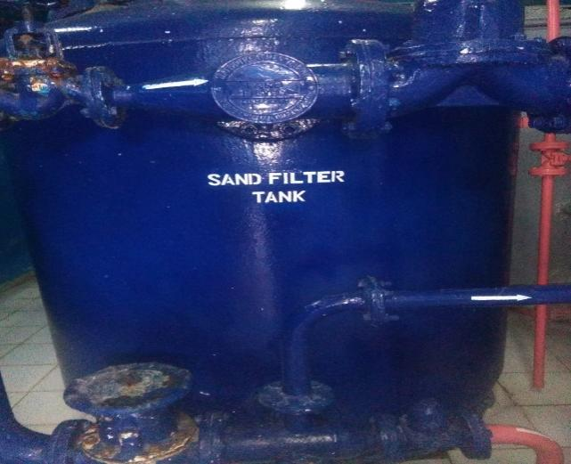

Figure 3 sand filter tank

The treated water that comes from coagulation tank enters in to the sand filter. In this tank there is small sand that is used to settle the lime. This used to remove the unwanted chemicals except chlorine from water. In the sand filter we can checked the lime dosage in the treated water, by using the formula: A= 2P-M

Where: A -is which tells us whether the lime treatment is correct or not

P-is phenolphthalein indicator

M -is will tell us if all bicarbonate was removed whether we have free lime present.

* When A is positive, that is 2P is >M this implies that free lime is present in the treated water.
* When A is negative, that is M is> P this implies that bicarbonate is present in the treated water.

For proper lime treatment A value should be in between 2 and 7.

#### **Carbon filter tank**

The treated water that comes from the intermediate tank is entered in to the carbon purifier. This is used to remove chlorine by using activated carbon that present in the water. The presence of chlorine can be changed the color and test of the final product (Pepsi, Miranda, 7up Miranda apple, Miranda orange and Miranda tonic). The chlorine dosage in the carbon purifier must be in between 6and8.

If the color can be c hanged the water has chlorine, therefore the treated water can be corrected by removed chlorine before enter in to the polisher. Because if the water that has chorine is passed in to the process can be changed the color and test of the product. Regeneration of activated carbon is takes place by the incoming steam from boiler room.

#### **Cartridge Filter (Polisher, 1micro Sized)**

This is used to remove suspended activated carbon that comes from the carbon purifier and other unwanted particle that may be passed through the carbon purifier before transferred to UV. The filter bag used for filtration is called polisher

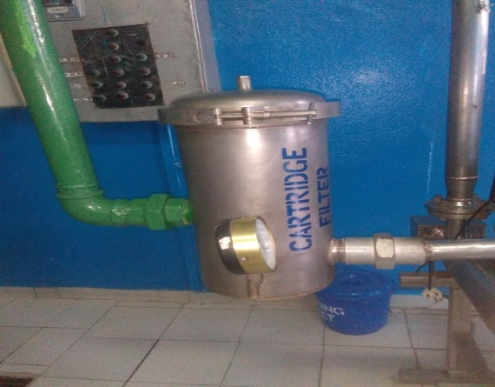

Figure 4 cartridge filter

The white colored polisher is the new/to be used by replacing the old one that used for one month period inside the Cartridge filter. Cartridge filter contains five polishers inside it as in the above arrangement for one month.

#### **Ultra Violet (UV) Radiation**

It is the final treatment for the product water. It is used for destroying any microorganisms present in water. It’s known as the critical control point for the quality of the water. After passing through UV, now the water can be used for production purpose, such as syrup preparation and filling room.

Water storage tanks → Water treatment by Coagulation tank → Sand filtration → Carbon (Activated) purifier → Polishing → UV → Treated water (for syrup preparation, filling…..)

#### **Softener Tank**

In almost every raw water supply, hardness is present as calcium and magnesium bicarbonate, often referred to as carbonate hardness.

From the storage tanker water is pumped in to the softeners in which hard water is converted in to soft water. The main function of the softeners is to soften hard water by eliminating Mg2+ and Ca2+ ions existing in their carbonate form. Two stage softener used in our factory. When one works other regenerate it.

In the first softener:

MgCO3+ NaAlSi2O6: H2O → Na2CO3 + Mg (AlSi2O6: H2O) 2

CaCO3+ NaAlSi2O6: H2O → Na2CO3 + Ca (AlSi2O6: H2O) 2

These reactions are continuous until the active site of sodium in zeolite complex compound is all occupied by Mg and Ca. The structure contains a relatively large central open area which allows large ions or other molecules to move through or reside within its frame. As a result, sodium zeolite can function as a chemical sieve. During the reactions since alkali metals are more active than alkaline earth metals; Mg and Ca are displaced from their carbonate compound by Na to form Na2CO3. Na2CO3 does not have an effect on the hardness of water.

In the second softener: In this softener sodium zeolite is regenerated by adding brine solution

Mg (AlSi2O6: H2O) 2 +NaClNaAlSi2O6 → H2O + MgCl2

Ca (AlSi2O6: H2O) 2 + NaClNaAlSi2O6: → H2O + CaCl2

Softened water obtained from the softener is transferred in to different rooms; such as boiler room, washer room and cooling room, chiller

Softener tank 2

Raw water

Lime

CaCl2

(So4)3

Cl2

**Sand Filter**

Carbon purifier

Cartridge filter

UV

Brine solution

Figure 5 block diagram in water treatment room

Coagulation tank

Softener tank 1

Soft water

Treated water

### **2.3.2 Boiler Room**

This room is one of the company’s essential units. It mainly produces steam for syrup room, bottle washer and sanitation. The main parameters used to produce steam are:- Furnace (Heavy oil), soft water and LVG gas. The reason behind for choosing furnace over fuel (Light oil) is that it is cheaper than fuel. A boiler or steam generator is a device which is used to create steam by applying heat energy to water. This generated steam has different functions in different sectors of the company.

Such as;

* for heating caustic soda in washing room
* To dissolve sugar in syrup room.
* Sanitation

There are three types of boilers namely, fire tube, water tube and electrical tube boiler. The plant uses fire tube boiler to produce steam. Fire tube boiler flame is move inside the tube and water is on the outside of the tube meaning on the shell side, while water tube boiler water moves inside the tube and flame on the outside of tube.

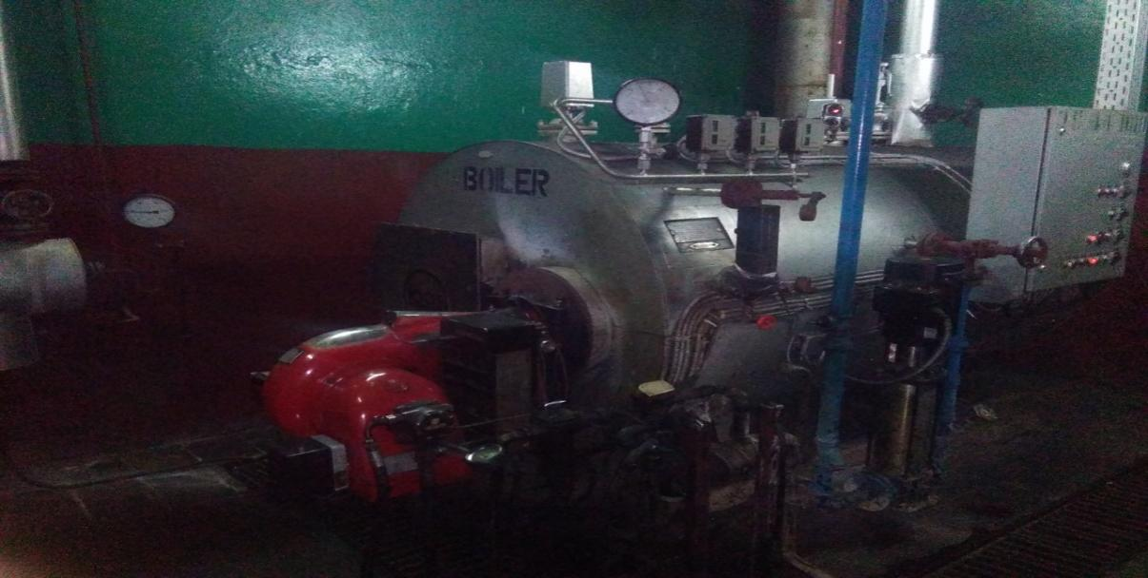

Figure 6 fire tube boiler

A boiler machine requires different raw materials to produce steam. These raw materials possess combustion process. During combustion the heat energy is produced. This heat energy is applying to the water inside the boiler tanker, then the water heated more and more it changes to steam which is required product.

The boiler machine requires sensor solenoids which controls the amount of water present inside its tanker. This simply indicates that when the amount of water present in its tanker is less, it opens the water valve from the reservoir water tanker, and when it is excess amount of water, it closes the reservoir water tanker. These two values are sensitive materials

### **2.3.3 Air Compressor Room**

An air compressor is a device that convert power (using an electric motor, diesel or gasoline engine, etc.) in to potential energy stored in pressurized air, (compressed air) having the following futures;

**In take air filter:** - prevent dust from entering a compressor, if the dust is gate in to the air compressor machine, there will be un masked for sticking valves, scoured cylinders, excessive wear etc.

**Inter stage cooler** : - reduce the temperature of the air before it enter the next stage to reduce the work of compression and increase efficiency they are normally water cooled.

**After cooler**: - is used to remove the moisture in the air by reducing the temperature in a water cold heat exchanger.

**Air dryer**: -the remaining trace of moisture after cooler are removed using air dryers. So by using this machine (Air dryer) the moisture content will be removed.  
**Moisture drain trap**: -is used for removal of moisture in the compressed air.

**Air reservoir tank**: - is serving as storage of compressed air

By one or several method an air compressor force more and more air in to a storage tank, increasing the pressure. When tank pressure reaches its upper limit the air compressor shuts off, the compressed air can be used for a variety of applications like: - utilizing the kinetic energy of the air as it’s released and the tank depressurizes. When the tank pressure reaches its lower limit, the air compressor turn on again and pressurizes the tank.

Due to adiabatic heating air compressor requires some method of disposing of waste heat. This is some form of air or water cooling, although some compressor way is cooled by oil. Generally in Gondar MOHA soft drink Company the air compressor is cooled by water, also its have 2 compressors and it works with 3 phase motor.

In order to treat or clean the moisture content of the air is gate in to dryer machine. The oil is used for the shafts or gear that drives by the motor so the oil is smoothest the shaft or the gear.

Use of Air Compressor in Gondar MOHA Soft Drink S .C

* Cleaning of the bottle
* Push the piston of the bottle on filling beverage
* Dry the moisture on the bottle by using video jet
* Cooling the beverage

### **2.3.4 Syrup Room**

Syrup is a condiment that is thick, viscous liquid consisting primarily of a solution of sugar in water containing large amount of dissolved sugar. Syrup preparation starts from simple sugar dissolving tank and ends in final syrup tank.

#### **i. Syrup Preparation Detail**

The process of syrup preparation is started from sugar treatment. The sugar is comes from India, Brazil, Dubai, Italy and Netherland in order to fulfill the quality of PepsiCo standard. Then this sugar is stored in the sugar storage room. For the treatment process we have to use hyflo or diatomite and activated carbon.

The process is started from adding of sugar in the sugar dissolving in tank the tank have 700L of water with 600c of temperature, then 1,128 kg of sugar is added in to the tank, in addition 1 kg of activated carbon is added in the sugar dissolving tank, then agitate in order to mix and weight until the temperature is rise in to 800c. The activated carbon is important for the odor and removing un-wanted thing in the sugar. In the other tank hyflo will mix with water in the tank in order to catch up or separate the activated carbon from sugar in the candle filter tank.

Through circulation the mixture of dissolved sugar and hyflo will be contact in this candle filter then the activated carbon will be coached by this hyflo then the pure sugar will be pass through the heat exchanger in order to loss its hotness temperature and gating to the syrup room. After all this process the simple syrup will be produced.

There are two types of syrup preparation in the production of soft drink plant, those are: -

* **Simple syrup**: - Is the mixture of water and granulated sugar
* **Finished (final) syrup**: - In this unit there are huge tankers and they used to store and

Convert the simple syrup in to the final syrup, but before these it should be cheek the brix and the amount of simple syrup. The next step is adding of flavor and other ingredients in to the tanker, but those ingredients are different for different soft drinks. Then agitate until the components are mix and it’s have a manual or standard for this work, so the chemists cheek the quantity and quality in every 4 hours, after all this final syrup will be produced.

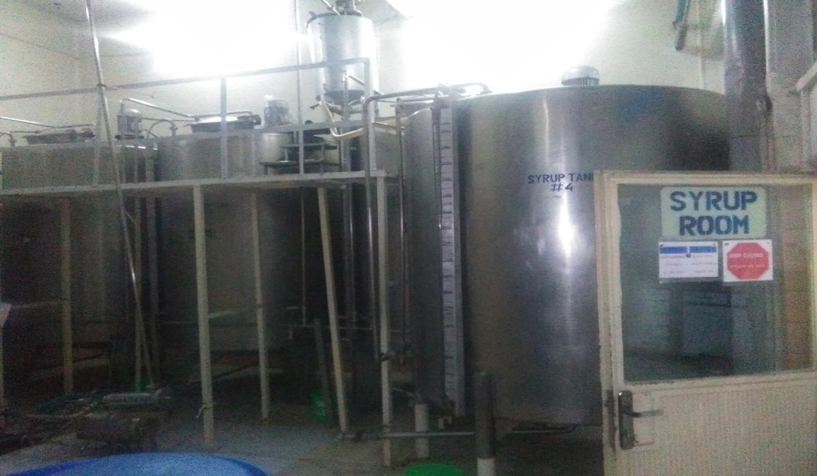

Figure 7 finished syrup reservoir

**Preparation of Pepsi syrup**

Pepsi which have Pepsi acidulate, Pepsi flavor, Sucrose granulated and treated wateringredients are very essential, and the first step is adding of 700L of treated water at 600c in to sugar dissolution tank, then we begin agitation by this time dissolve 1,128 kg of sucrose granulated in to sugar dissolution tank and by using agitator we mix it and also the temperature will be rise in to 800c .at this time the simple syrup will be produced so it should have to cheek or test the color, turbidity and brix of the simple syrup, then transfer simple syrup from the dissolution tank through filter to the syrup mix tank. After agitation the next step is adding of 18.930L (24.730) kg of acidulates to the syrup mix tank, then rinse Pepsi acidulates container with 4.000L (3.989) kg of treated water and transfer in to the syrup mix tank. Next 3.785L (3.918)kg of Pepsi flavor will be added in to the syrup mix tank and rinse Pepsi flavor container with 4.000 L of treated water and transfer in to syrup mix tank , and agitate until mixed.[from the workers] After this entire step stop agitation of syrup and test the brix, total volume and specification of finished syrup. Then hold the syrup for 24 hrs.

#### Preparation / processing instruction for Miranda

**Syrup preparation for marinade orange and the Ingredients for Merida orange:** -

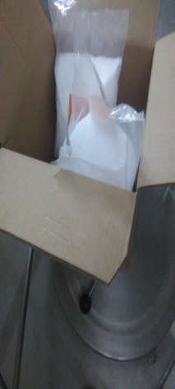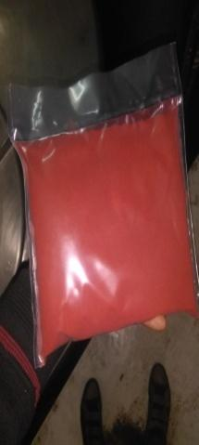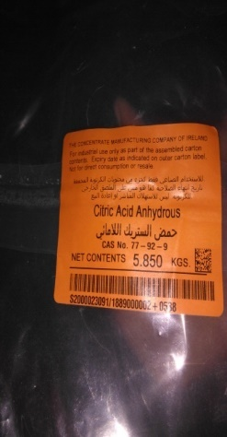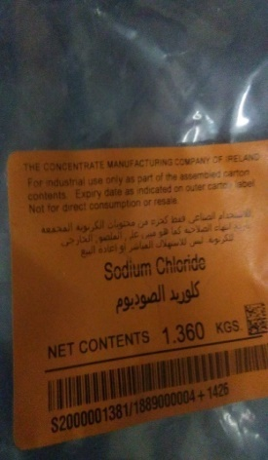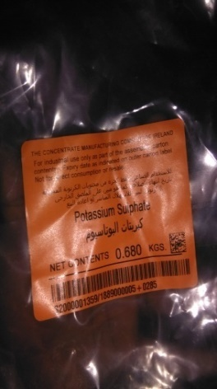

Figure 8 figure 8 solid ingredient of Miranda

* + Citric acid it’s organic acid that prepare acidic media and preventing from mold and bacterial contamination
  + Sunset yellow: it’s a chemical that bring the desired color for the final product
  + Sodium chloride: it contribute for the better test of the product and also for long shelf life
  + Potassium sulfate: it’s a chemical that makes our product soft drink & makes it sharp
  + Benzoate: it’s a preservative that use to prepare our product
  + Liquid Flavor: that brings the desired orange flavor to our product.

Dissolve 0.940 kg of sodium benzoate in 4 L treated water, then add to the tank and agitate until completely mixed. Then add 11.70kgs of citric acid anhydrous, 1.360kg sodium chloride, 0.680kgs of potassium sulphate, and 0.345kgs of sunset yellow (color) and mix them with the agitator and then add orange flavor (30.05kgs). This is for 2 unit finished syrup preparation which is 2600L in volume. Finally, the brix of the syrup test by chemists and if it fits to the standard; it will go to production line.

Table 1 standard for finished syrup

|  |  |  |
| --- | --- | --- |
| **Batch No** | **Pepsi cola** | **Miranda orange** |
| Water for dissolving(L) | 700 | 450 |
| Water for pushing(L) | 100 | 25 |
| Sugar used(Kg) | 1128 | 858 |
| Simple syrup brix (%) | 53.4-54.1 | 52.7 |
| Finished syrup brix (%) | 53.7 | 51.1 |
| Flavor (unit) | 1 | 2 |
| Simple syrup volume(L) | 3200 | 2400 |
| Finished syrup volume(L) | 3400 | 2600 |

### **2.3.5 Bottle Washer**

The bottle washer clean and sanitize returnable bottles that have been brought back from the trade. Returnable bottles are rinsed to remove beverage residues, straws and any liquids or suspended material. High strength of caustic, caustic based detergent, or caustic with other additives, at elevated temperatures are used to clean and sanitize the bottle. The bottle washer takes dirty bottles from the trade and subjects them to:

* Water and caustic rinsing
* Soaking periods in hot caustic
* A number of inside and outside fresh water flushing’s with sanitary

Water to deliver a clean and sanitary bottle to the conveyer ensure route to the filler. For glass bottle extending soak time can allow a slight reduction in the basic requirements. Washed bottles that exist the washer should be checked for caustic carry over at start up and during operation. Checking for caustic carryover should be performed at start up and twice per shift, testing a complex row of pockets at the bottle discharge station of the bottle washer and during production every two hours 3 additional bottles should be spot checked. Generally the washer section is the major part of the company. In this section the process become started by selecting the most defect bottles by using manual inspection then transfer in to the washer machine by using bottle conveyor. The soap can be added in to the conveyor in order in to reduce friction between the conveyor and the bottles. then the bottle is intend in to the washer machine.

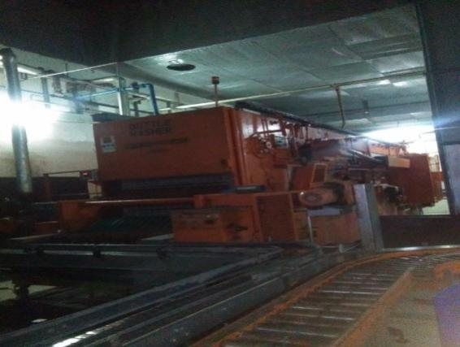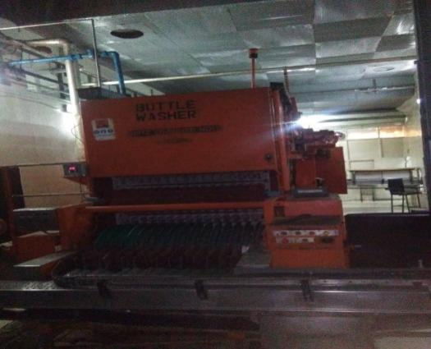

Figure 9 bottle washer

This machine uses different chemicals for washing bottles. These are:-

* Steam: which comes from the boiler room
* Caustic soda: for washing bottle after dissolving in a dissolving area with water at 75 up to 82 degree centigrade.
* Water: comes from water treatment room.
* DIVOBRITE: - It is a chemical used to strengthen caustic soda during washing. It will be added in each 5minute in caustic one and in each seven minute in caustic two for 15 seconds.
* DIVO LE: - This chemical is used to remove scale formed during the drainage and also in addition it uses to dry the jolliness’ and the foam occurred because of the caustic.
* DIVO NP: -It used to control the PH value of the water in the bath.
* Chlorine: - It used as disinfectant. It is added on warm water and it kills microorganisms if any.

NB: - DIVO LE & DIVO NP are both added on the cold water.

These chemicals are the bottle washing elements that washes in their own steps. The washing machine washes the bottles and gives to the drier machine which dries the bottles and transfer to the conveyor. After this the conveyor feeds the bottles to the filler machine continuously. The following steps show the procedure of the washing machine when it washes the bottles.

Returned Bottle (sales)→empty bottles stores/sales→ De palletizing→ Declassing→ Sorting→ Neck inspection→ Pre rinse clean→ Caustic soak→ Caustic spray jet→ Warm Water spray→ Final rinse (Cold water) →Fresh water spray jet→ Clean bottles discharge →Inspection

This machine is very important and usable to be effective for bottle washing and it’s suitable to wash that bottle with a little (minimum) amount of time and labor. The bottle is waiting for 30 minute in the washer machine until in late up to final out, and it pass different stages.

**Pre-rinse:** -This is the first stage for bottle washing and the bottle is wash internally and externally with soft water by using spray jet.

**Caustic 1**: -After pre rinse the bottle is going to caustic 1, this is a kind of bath and in this bath there is 7000 L of caustic soda solution, also the caustic strength is must be 2 – 2.5 in scale and the chemists is cheek this scale in every 4 hour, and the amount of caustic is 100 kg In this section the temperature of caustic soda is must be 650C. Caustic 1 is used for removing of the bacteria and microorganisms inside and outside of the bottle.

**Caustic 2**: -The difference between caustic one and caustic two: -the strength of caustic in caustic 2 is less than caustic 1(or it measure 1 - 1.5 in caustic 2) and also the temperature is decrease by sum amount like 25 -280C from caustic 1.

**Warm water**: -The temperature of this warm water is 45 -480C and the bottle is washed internally and externally by using spray jet hole, those spray jets have 15 holes. Cold water: -Also wash the bottle with cold water.

**Final rinse**: -This is the final stage for bottle washing process and the water is comes from water treatment room, so the water is clearly treated in order to protect the bottle from microorganism and other un-desire things.

### **2.2.6 Filling room**

Process takes place in the filling room:

* Empty bottle inspection
* Mixing
* Filling
* Crowning
* Full bottle inspection and
* Date coding

#### **Empty Bottle Inspection**

In this process the washed bottles are inspected manually by peoples and electrically through light screening in order to check any untreated bottle. The inspection includes properly unwashed bottles, rust and bottles that cannot be used for specific kind of product. The purpose of inspection is to insure the safety of the work in the processes. People inspect manually 150 bottles per minute and 18,000 bottles per hour

#### **Mixing & cooling**

The basic purpose of this room is to mix the three main contents of the product, which are water, finished syrup and carbon dioxide. This process is called Carbonation. The water comes from water treatment room and it is well-treated water and the finished syrup comes from syrup room whereas the carbon dioxide comes from CO2 reservoir. There are two tanks under mixer machine; these are dosing tank and water tank used to receive the finished syrup and the treated water respectively. Flowing out from their own tanks the syrup and the water will mix in the pipe in 1 to 5 ratios for Pepsi and 1 to 4 ratios for Miranda. They mixed depending on the standard ratio of PepsiCo international.

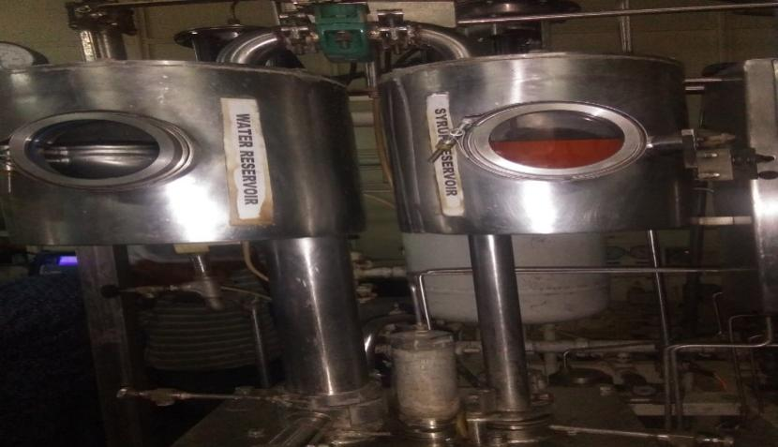

Figure 10 water and syrup reservoir for mixing

After the syrup and water are mixed regarding to their ratio, CO2 will be added on the mixture. There is no material to receive carbon dioxide, it just comes online and mix with the water and the syrup and will get into the carbonation tank. There is also a standard for carbon dioxide added. Carbonation tank is used to dissolve the CO2 thoroughly in the mixture. When the CO2 completely mixed with the mixture then it is called a final product and will be ready for filling. Before CO2 combined with treated water and syrup it should be cool by carbon cooler in order to dissolve CO2 .because CO2 is a gas, it dissolves at low temperature and high pressure .the objective of cooling CO2 is to preventing foaming during filing and also prevent under filing. As the beverage is chilled, it absorbs carbonation. Most beverage operation use cooling to 20oc for cold filling. The finished beverage is cooled by ammonia gas; the cooling tower for ammonia compressor is available in the company.

#### **Filling**

Filler is a machine which is used to fill the bottle with the drink that has been prepared in the Para mix. It is connected with the Para mix and the crowner cork. This machine has bowl pressure, bowl level, bowl liter, capacity, mode filler, bottle counter and temperature and controlled by PLC system. These all things have their own purpose. The various filling processes are selected at the operator panel. First the drink is stored in the bowl and above this drink car bon dioxide gas will be placed and then when the empty bottle is transported by the in feed conveyer through the in feed worm gear which pushes the bottles in sequenced manner. Then the bottles are pressed against the filling valve by a lifting element called piston. The piston will perceive the existence of the bottles during the lifting process. If the bottle is present the processes is started and the bottle is filled. The corresponding filling valve remains closed if the bottle is missing. The machine works by lubrication system automatically .there are also 15 filling valves called vents and expanding tubes where these tubes have small holes that are used to transport the gas as well as the drinks respectively. In this section the co2 should be filled first in the bottles in order to balance the temperature and pressure as well. When the fluid (drink) poured in to the bottle the gas occupying the remaining space of the bottle goes up to the returned gas media through the vent tube.

Table 2 faults on filler and possible causes

|  |  |
| --- | --- |
| ***Faults on filler*** | ***Possible causes*** |
| Bottle not properly filled | * Bottle mouth damage * Lifting cylinder pressure to low * Filling speed to high * Amount soft drink is low |
| Bottle fobbing over when with drawn | * Dirty bottle * Filling pressure to low * Temperature of the beverage is to high |

#### **Crowner**

It is a device used to seal the bottle with crown corks. It has cork feeder on top part, the cork drop by the action of gravity to seal the incoming full bottle.

#### **Full bottle inspection**

#### Filled bottles are also inspected manually and by EBI. First they are inspected by EBI for any defect i.e. if the crowns are not placed at the right place or if the bottles are perfectly filled. Manual inspection is done by people who check if the bottle is of the right fill height. Products should not be under filled or over filled.

#### **Date coder**

The date coder is a machine that can print codes at elevated line speeds on consumer and industrial products. The printer delivers superior uptime, excellent quality and ease of use to the users. Its use is to print manufactured date and expiration date on the bottles. And it has no contact area with the bottle it only prints the date by spraying the ink through the print head.



Figure 11 date coder

#### **Packing**

The purpose of packing is to arrange the full & empty bottles in a proper order for the safety of the bottles. In Gondar Pepsi cola plant packaging is done manually. The full bottle in the case is will put by human.

### **2.3.7 CIP Method**

CIP process is the basic activity conducted in beverage plants. In Gondar Pepsi cola plant CIP (cleaning in place) is a two-type of cleaning method. Those are:

* First rinse by 50OC- 60OC water for 10-15 minutes
* Cleaning by 50OC -60OC using caustic soda for 20 minutes and the concentration of this soda should be in between 0.5%-2%.
* Rinse by 38OC water for 10-15 minutes then checking for the absence of chemicals
* Sanitize either by hot water at 80OC for 15 minutes or chlorine at 100ppm concentration for 20 minutes
* Rinse by fresh water for 10-15 minutes then checking the absence of chemicals.

### **2.3.8 Quality Control Section**

As a Pepsi cola plant and food handling company Gondar Pepsi cola plant follows standards which ensure to apply a good manufacturing practice so as to produce safe and quality products. The standards have their own audit program regularly (weekly, monthly, quarterly, by the plant committee, which are certified management members and annually by third party). The standards applied are the following:-

**GMS**: - is a good safety system which layout, control and evaluate the implementation of the Training, Personal hygiene and Company visits health checks programs

**HACCP**: - it is a safety management system with Food safety policy, HACCP team description, Prerequisite programs description, Hazard analysis program:-

**QAS**: - this procedure applies to all Pepsi Co beverage plants, franchises, and co-packers.

**EMS**: - this is establish and implement a functional waste collection and disposal system for solid wastes generated by households, factory and office operations,

The overall processes in the company can be checked in this section. According to the laboratory test whether the processes continue or not can be decided in this section. One of the main goal of the quality control is to present the consumer with a product that is not consistently with in standards, but that has a long shelf life .the primary purpose of quality control and plant testing program is

* The beverage meets prescribed standards.
* The production lines and processing systems are functioning properly.
* The syrup is prepared correctly.
* The all ingredients used in preparing syrup and final beverage and correctly treated, handled, stored and within standard.

# CHAPTER THREE

## **3. Material and energy balance**

### **3.1 introduction**

A material balance in its most broad definition is the application of the conservation of mass which states matter is neither created nor destroyed. Matter may flow through a control volume and may be reacted to form another species, however, no matter is ever lost or gained. The same is true for energy as with material balances, we can apply the law that energy is neither created nor destroyed; it is simply converted into another form of energy. The law of conservation of mass and energy leads to what is called a mass (material) and energy balance.

**Law of conservation of mass**: it is the law which states that mass can neither be created nor destroyed. Thus in a processing plant, the total mass of material entering the plant must equal to the total mass of leaving the plant. Here accumulation is assumed to be zero.

Mass In = Mass Out + Mass Stored

Raw materials=Product+Waste Products+Stored Products+Losses

Before we proceed further on developing the material and energy balances, let’s first discuss briefly some important terms:

* **Steady-state process** is one where none of the process variables change with time.
* **Unsteady state (transient) process:** it describes condition at which the process variables change/continuously evolve over time.
* **Continuous process** is one that the feed streams and product streams moving into and out of the process all the time.
* **Batch process** is the process one where the feed streams are fed to the process to get it started. The feed material is then processed through various process steps and the finished products are taken out at a specific time.
* **A semi-batch/semi-continuous** is a process that has some characteristics continuous and batch processes.

### **3.2 material balance**

A material balance (also called a mass balance) is an accounting of material entering and leaving a system. Material balance can be applied to entire processor any unit operation. Whatever its nature, the input streams (mass and energy) always balance with the output flow streams (mass and energy).

**The material balance Equation**

The fact that matter and energy cannot be lost nor gained can be extrapolated into the basic, most general form of the equation, which is as follows:

INPUT-OUTPUT=ACCUMULATION

If the process is at steady-state, there is no accumulation of mass within the process. Thus

INPUT=OUTPUT

When we apply this equation to a process, it is best to write it as:

Ʃmasses entering via feed streams = Ʃmasses existing via product streams

Ʃmass in = Ʃmass out ………………………………for a batch process

Ʃmass in by flow = Ʃmass out by flow ……………for a continuous process.

## ENERGY BALANCES

Energy is the capacity to work or to transfer heat. The law of conservation of energy states that energy can neither be created nor destroyed. The total energy in the materials entering the processing plant plus the energy added in the plant must equal the total energy leaving the plant. This is a more complex concept than the conservation of mass, as energy can take various forms such as kinetic energy, potential energy, heat energy, chemical energy, electrical energy and so on. During processing, some of these forms of energy can be conserved from one to another. When we think about energy the following terminologies are always reminded on mind.

* **System**a quantity of matter or a region in space chosen for study.
* **Surrounding** it isthe region outside the system.
* **Boundary** a real or imaginary surface that separates the system from its surroundings.
* **Closed system** a system where nothing leaves to its boundary. Any truly closed system would have to be completely insulated or completely isolated.
* **Open system** in this type of system there is a mass transfer across the system’s boundary. Most systems are categorized under this system type.

**The general energy equations**

Esystem = Ein-Eout …………………………. (1)

Esystem =∆U+∆KE+∆PE ………………….. (2)

Then by combining these two equations, the energy balance will expressed as

Ein-Eout =∆U+∆KE+∆PE

If a system does not move with a velocity and has no change in elevation, it is called **stationary system** and the conservation of energy equation reduces to:

Ein-Eout =∆U

But, ∆U=∑Q+∑W =Qin-Qout +Win-Wout

Finally, the energy equation can be reduced into

Esystem=Ein-Eout=Qin-Qout +Win-Wout

**N.B** The significance of doing Material-Energy balance mainly includes;

* To quantify the material, energy and waste streams in a process or a system.
* To know the quantitative amount of materials entering into a process
* To find out the unknown losses and emissions of the material & energy in the process.
* To monitor the improvements made in an ongoing project and while evaluating cost benefits by the top management.
* To take quick remedial actions.

**Mass balance on Miranda**

**Material balance on some unit of operation**

Flow diagram carbon=1kg

Water=450kg

Sugar dissolved thank

M out=?

Mass fraction of each =?

Sugar=850kg

Min=Mout

Min=450kg+850kg+1kg=1301kg

Sugar balance mass fraction(x)

X= = 0.653

Water balance mass fraction (x)

X= = 0.3346

Carbon balance mass fraction (x)

X= =0.00077

Mass balance on filter plat

Hyflo=8kg

Fitter plate

Dissolving= 1301kg solution M out

Min=Mout

Mout=total mass of solution-mass of carbon-mass of hyflor

=1301kg-(1-8) kg=1292kg

Water balance mass fraction(X)

X== 0.348

Sugar balance mass fraction(X)

= 0.658

Mass balance on finished syrup

Citric acid=5.850kg

Flavor=30kg

Finished syrup tank

Simple syrup=1292kg M out

Water**=**4kg

Potassium sulfate=0.68kg

Nacl=1.360kg

Sodium benzoate=0.940kg

Sunset yellow=0.345kg

Known value

**-**mass simple syrup= 1292kg

-mass of water that added with different comments= 4kg

-mass of flavor=30kg

-mass of citric acid=5.850kg

- Mass of Potassium sulfate=0.680kg

-mass of sodium chloride=1.360kg

- Mass of sodium benzoate=0.940kg

-sunset yellow=0.345kg

Min= M out

Min=1292+4+30+5.85+1.360+0.345+0.940+0.680=1335.175kg

X is percentage of mass

X=Mi/M total

Sugar balance

X= =0.967

Water balance

X = = 0.00299

Flavor balance

X == 0.02247

Citric acid balance

X == 0.00438

Potassium sulfate balance

X == 0.0005

Nacl balance

= 0.001

Sodium benzoate balance

= 0.00070

Sunset yellow balance

X == 0.0002546

**Mass balance on Pepsi**

**Mass balance on sugar dissolving tank**

Water=700kg M out=?

Sugar dissolving tank

Mass fraction=?

Sugar=1128kg

Carbon=1kg

Known value; -mass of water=700kg

-mass of sugar=1128kg

-mass of carbon 1kg

Min=Mout

Mi=700kg+1128kg+1kg=1829kg

Water balance

X=mass of fraction

X= 0.38

Sugar balance

= 0.62

Carbon balance

= 0.00055

### **3.3 Energy balance**

**Energy balance on boiler**

73.8% heat steam

Fuel 100% consumption

Steam Boiler

Energy content of fuel the other is west the other 26.2% is west

Is 7594kw/liter

Pump energy=2.5kw/h

Energy generation by steam boiler =energy content of fuel + motor energy the steam boiler use 40liter /H fuel

Ein=7594kw/liter0liter/h=303760kw/h+2.5kw=303762.3kw/h

From this only 73.8% is steam energy

Stem energy=73.8%303762KW=22, 4176.7kw/h

Lost energy=26.2%303762.3kw/h=7,6585.7kw/h

Note lots of energy on boiler because of the flowing factors

1. Heat loss due to radiation & other unaccounted loss=1.0%

2. Heat loss due to moisture in air =0.3%

3. Heat loss due to unborn in residue=2.4%

4. Heat loss due to moisture in fuel= 1.7%

5. Heat loss due to hydrogen in fuel=8.1%

6. Dry fuel gas loss=12.8%ss

# CHAPTER FOUR

## **4. Environmental & socio-economic analysis**

### **4.1 environmental analysis**

Industry can have various impacts upon the environment depending upon the activity taking place. Modern high technology industries tend to have lower impacts upon the environment than older traditional heavy industries such as the manufacture of steel of the production of chemicals. Industrialization is important for economic growth and development of a society but can also be harmful to the environment. Amongst other things, industrial process can cause climate change, pollution to air, water and soil, and health issues.

* **Air pollution:** Industry is a major cause for air pollution since the operation of factories results in the emission of pollutants. Minute particles called particulate matter are damaging when breathed in sulfur dioxide (SO2) and nitrogen oxides (NOX) can cause acid rain and CO2 can cause global warming. These pollutants and others can both harm public health and damage the environment.
* **Water pollution:** Industries use a lot of water and correspondingly can produce a lot waste water too. Waste water is called **effluent** and can come from industrial outlets, treatment plants, and sewers. This waste water pollutes underground reservoirs of water and our rivers, damaging wildlife and ruining potential drinking water.
* **Land pollution:** Heavy industries use lots of land and often deal with very hazardous chemicals. These were dumped on industrial sites in the past or industries suffered leakages onto the land and soil. Examples of soil pollution sources are oil refineries and pipelines transporting gas, oil deposits, gas stations, garages, metal treatments and coating factories, chemical plants, dry cleaning businesses, printing businesses, the textile industry and sites where hazardous materials are stored. These sources of pollution can cause serious damage and added to this there is the potential for marine and coastal pollution too. Finally, large industries pose problems because they are noisy. Frequent of prolonged exposure to loud noises is not only a nuisance but can cause to a person’s physical and mental health.

### **4.2 socio-economic analysis**

In Gondar Pepsi cola plant there is good social interaction between workers

That means each worker work its own activity during the required time and in subscribed space

They are helping each other when problems happened in specific machine.

Workers are respect each other and they are also open to answer our question.

There is good cafeteria for every worker in the company. Which has an important role to save lunch time.

Economically the company gets much income from the products. But there is also an expense to different purposes like

* Buying different chemicals
* Salary for workers
* Sponsorship
* Transportation for selling

The company is wasteful of products due to under full and overfull of bottles. This loses much products which is underflow to the ground by the case of uncrowned and when bottles are broken at its tip.

# CHAPTER FIVE

## **5. Case study**

### **5.1 The challenges faced in the hosting company**

Gondar soft drinks Company is one of the soft drinks factories in our country located North of Ethiopia. Even so, this company can work 18-24 per day and supplies it’s standardized, qualified and before dated products to the traders, organizations and customers. There are many problems faced in this company. The problem that I have select for my case study project is the problem related to characterization of waste water effluent. The problems are environmental impact and defalcate of water.

### 5.2 Characterization of wastewater effluent in gpcp

### **5.2.1 Introduction**

Now a day the main concern of this world is environmental pollutions. So many wastes released from the industries can affect the global status of nature. Specifically the waste water emitted from the factories causes a serious of problems in large portion of water (seas, leak and rivers) and on human’s well beings. The water that released from the industries may be solid, liquid and gas; all of the three wastes have no effect on the same way that other do but, all of them potentially and ultimately polluting the water in different ways.

Soft drink industry forms a large part of the food and beverage industry. Thus it is important to study the nature and amount of wastewater generated from the soft drink plants. Water is an essential raw material in the soft drink production. The wastewater generated in this industry is mainly from bottle washing, filler backwashing, washing of bottle machine, equipment’s, floors and pipe work during flavor changing.

Wastewater reuse is an essential factor in water resources management in industrial activities and development .The high water consumption and demand exceed the local resources, resulting sub regional deficit. The soft drink industry produces constitute of different effluents, therefore reuse or internal recycle should be seriously considered when planning water supply and resource managements.

In order to reduce water consumption and volume of wastewater in soft drink plants, the sources of wastewater uses should be identified then, measuring and monitoring the various pollutants in the wastewater are to be performed. Process for soft drinks typically pollutes the process water with sugar and other easily biodegradable substances. Pollutants in wastewater generated from soft drink industries are also due to the fact that they are mainly composed of washing water from production lines which is derived from the ingredients used in the final production.

Much of GPCP wastewater is generated from bottle washer continuously during production of Pepsi and Miranda. There is a generation of wastewater from syrup room during simple syrup & filter washing. Washing process takes 10-15 minutes. Wastewater is also generated from water treatment room during backwashing of sand filter & carbon purifier. 3 step & 5 step sanitation generates much of wastewater within 1 hour to 2 hour time interval.

Wastewater characterization studies are conducted to determine the physical, chemical and biological characteristics and the concentration of constituents in wastewater, and the best means of reducing the pollutant concentrations and reduce water defalcate. The main objective of this study is primarily waste water treatment design and physic-chemical characterization of waste water discharge from GPCP.

### **5.3 statement of the problem**

Now a day, there is shortage of water. Since the usage of waste water after treating provides reduction in water scarcity as well as several other environmental benefits. Treated water gives less environmental risk than in untreated water (waste water).

### **5.4 Significance of the project**

* To form environment sustainable
* To sustain (conserve) water
* To use this treated water for different purpose (gardening, agricultural and soon)
* To minimize health effect of waste on urban, rural and personnel working in the factory
* To remove pollutants most efficiently and economically.

### **5.5Objectives**

### **5.5.1 Generals objective**

The main objective of this project is primary waste water treatment design and physic- chemical characterization of waste water discharged from GPCP.

### **5.5.2 Specific Objectives**

* To investigate the Physic- chemical properties of liquid waste generated from hosting Company.
* To identify the waste potential and sources from the company
* To select primary waste water treatment plant for hosting company

### **5.6 Scope of the project**

The existing waste water treatment plant (WWTP) at GPCP is incapable of reaching the required effluent standard. When measure the turbidity, PH, TDS, temperature and others all are far from standards. So to characterize Physio- chemical parameters, design primary waste water treatment devices and select the better devices clearly to reach standard.

### **5.7 Literature review**

Waste water quality management and Regulation Based on the responses from the companies participating in the South African survey, the result indicates that the majority of the soft drink manufacturers have not implemented waste water management programs at their sites. In general, these companies do not comply with the limits set by the local authorities for pollution concentrations, and in particular the COD limits. So some best practice options for the management of waste water is provided in this section.

The recently formed Department of Water and Sanitation (DWS, 2014 – formerly the Department of Water Affairs (DWA) and the Department of Water Affairs and Forestry (DWAF)) is the water and sanitation sector leader in South Africa. DWS is the custodian of South Africa’s water resources and of the National Water Act (Act 36 of 1998) (DWAF, 1998) and the Water Services Act (Act 108 of 1997) (DWAF, 1997). DWS is also the national regulator of the water services sector. The National Water Act provides the legal framework for the effective and sustainable management of water resources within South Africa. The Act aims to protect, use, develop, conserve, manage and control water resources as a whole, promoting the integrated management of water resources with the participation of all stakeholders (DWAF, No date).

The Act stipulates the requirements for, among others, the development of a National Water Strategy and Catchment Management Agencies, the protection of water resources through classification, setting reserves (basic human need and ecological), determining resource quality objectives and promoting pollution prevention, and through the provision of penalties for non-compliance. The Water Services Act Deals mainly with water services or potable (drinkable) water and sanitation services supplied by municipalities to households and other municipal water users. It contains rules about how municipalities should provide water supply and sanitation services. Within each municipal area, by laws are developed which outline the water supply and effluent discharge regulations and tariffs for that area.

Under the National Water Act (Act 36 of 1998), norms and standards for the purification of waste water or effluent prior to discharge have been set. These consist of general and special standards and set limits for aspects such as PH, temperature, chemical oxygen demand (COD), suspended solids, metals, etc. The test method that is to be used to determine these levels are also specified. Areas where the special standards apply are listed. Any industries or municipal or private waste water treatment works discharging to river or sea must comply with these limits. In turn, the entity operating a waste water treatment works must set limits for industries discharging to the works such that the DWS final discharge limits can be met. The constitution of South Africa states that everyone has the right to an environment that is not harmful to his or her health or wellbeing (SA Government, 1996) and the right to have the environment protected, for the benefit of present and future generations through reasonable legislative and other measures that prevent pollution and ecological degradation; promote conservation; and secure ecologically sustainable development and use of natural resources while promoting justifiable economic and social development. Regulation that addresses these rights falls under the responsibility of the Department of Environmental Affairs (DEA).Policy that is the most relevant to the soft drink sector is the National Environmental Management Act, 1998 (Act 107 of 1998) and in particular, the National Environmental Management: Waste Act, (Act 59 of 2008) and the National Environmental Management: Air Quality Act, 2004 (Act no. 39 of 2004). Broadly speaking, these Acts outline the requirements for the storage and handling of waste onsite (hazardous and nonhazardous), licensing requirements, the establishment of waste management plans, the setting of limits for air emissions, and the setting of penalties for offenses. Both these acts emphasize the need for the implementation of cleaner production and clean technologies to reduce the generation of pollution at source. These Acts have been amended more than once to update requirements a new technology are developed and environmental protection has become more of a priority.

Table 3 standard value of treated water

|  |  |  |
| --- | --- | --- |
| No | Parameters | Standard Amount |
| 1 | PH | 6-9 |
| 2 | BOD | < 30 mg/l |
| 3 | COD | < 200 mg/l |
| 4 | TDS | < 50 mg/l |
| 5 | TSS | < 30 mg/l |
| 6 | Temperature | 37 0c |
| 7 | N | 4.00 mg/l |

### **5.8 Methodology**

### **5.8.1 Apparatus**

PH meter (used to measure the acidic, basic and neutrality of the waste water), conductivity meter (used to check the total dissolved solid in the waste water), beakers (used to handle a liquid), measuring cylinder (used to measure the volume of a liquid), thermometer (used to measure the temperature of the waste water).

### **5.8.2** **Equipment**

Screen (removes objects such as crown, broken bottles and metals to prevent damage and clogging of downstream equipment and piping), Grit chamber (grit chamber is the second unit operation used in primary treatment of waste water and it is intended to remove suspended inorganic particles such as sandy and gritty matter from the waste water),Sedimentation tank (allows suspended particles to settle out of waste water as it slowly through the tank, thereby providing some is periodically removed).

### **5.8.3 Chemicals**

Lime, aluminum sulphate (used for coagulation and flocculation purpose), Waste water (sample taken to study), sodium hydroxide and sulfuric acid (used for PH adjustment) and chlorine (used for disinfection).

### **5.9 Procedure**

First chemicals and materials were taken and put on working place. Then apparatus calibrated by distilled water. For PH meter by using buffer solution. Next waste water sample was taken from syrup room, washer room, CIP room, production room and total collected waste water the PH, temperature and TDS of waste water were measured by using PH meter, thermometer and TDS meter respectively.

### **5.10 Method**

We use different data collection methods to collect the data such as from Google, by asking laboratory technicians & operators, by measuring and laboratory test.

### **5.10.1 Primary waste water treatment**

As waste water enters a plant for treatment, it flows through a screen, which removes large objects. After waste water has been screened, it passes into a grit chamber, where cinders, sand, and mud settle to the bottom. After screening is completed and grit has been removed, waste water still contains organic and inorganic matter along with other suspended solids. These solids are minute particles that can be removed from waste water in a sedimentation tank. When the speed of the flow through one of these tanks is reduced, the suspended solids will gradually sink to the bottom, where they form a mass of solids called raw primary bio solids formerly sludge.

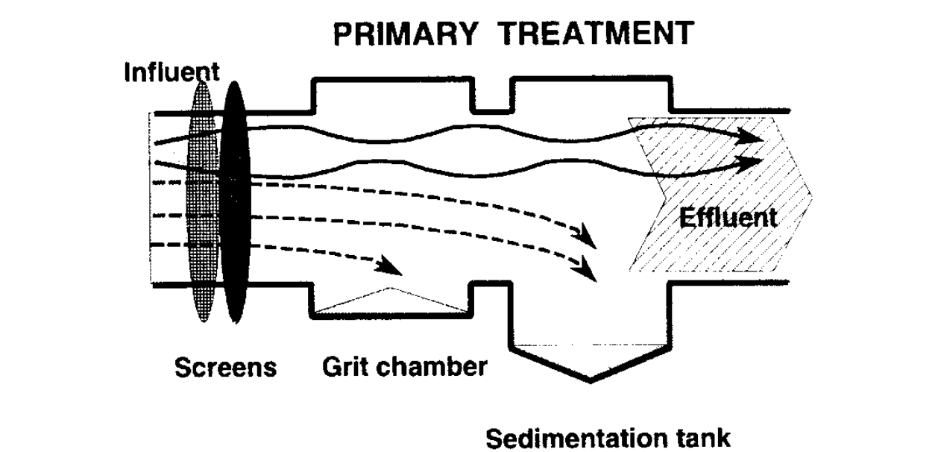

Figure 12 shows how primary treatment works

### **5.10.2 Screen**

Screening is the first unit operation used at wastewater treatment plants (WWTPs). Screening removes objects such as rags, broken bottles, cork, paper, plastics, and metals to prevent damage and clogging of downstream equipment, piping, and appurtenances. Some modern waste water treatment plants use both coarse screens and fine screens.

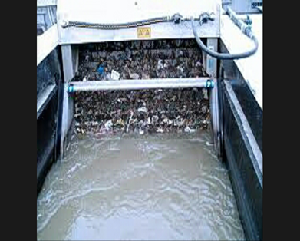

Figure 13 screen

**Screen selection**

There are different types of screen. From those we select coarse screen because.

* It has less pressure drop
* It has high surface area for liquid flow
* It has low resistance for liquid flow

**Design of coarse screen**

To design screen for waste water treatment the following things to be considered.

**A. Velocity**

The velocity of flow ahead through the screen varies and affects its operation.

The lower the velocity through the screen, the greater is the amount of screening that would be removed from sewage.

However, the lower the velocity the greater would be the amount of solids deposited in the channel. If the deposition exists, it indicates the flow velocity is low. Hence, the design velocity should be such to permit 85-100% removal of material of certain size without undue deposition. Velocity through the open area from 0.6 to 1.2 m/s for the peak flows is satisfactory. So we will be select 0.9 m/s.

**B. Head loss of screen**

Head loss varies with the quantity and nature of screening allowed to accumulate between cleanings. Head loss through screens mainly depends on:

* Size and amount of solids in waste water
* Clear openings between bar
* Method of cleaning and its frequency
* Velocity of flow through the screens.

The head loss through coarse screen is calculated from the following formula: h =0.0729 (V2– v2) Where,

h= head loss in m V=velocity through the screen in m/s Assume; V=0.9 m/s v=velocity before the screen in m/s

v=0.5 m/s =0.0729 (V2 – v2)

=0.0729 (0.92 – 0.52)

=0.0484

The area of screen is calculated asArea (As) = flow rate (Q)/velocity through the screen (V)

But, Q=175.8m3/day is discharge to the screen from this industry

=175.8m3/day \* 1 day/24 hr. \*1 hr. / 60 min \*1 min/60 sec

=0.00203m3/sec.

As=0.00203m3/sec /0.9 m/s = 0.0226 m2

### **5.10.3 Grit chamber**

Grit chamber is the second unit operation used in primary treatment of waste water and it is intended to remove suspended inorganic particles such as sandy and gritty matter from the waste water.

**Selection of grit chamber**

There are different types of grit chamber. From those we select horizontal flow and aerated grit chamber. Because

* It is extensively used at medium and large-size treatment plants.
* It is used for chemical addition, mixing, and flocculation before primary treatment.
* It offers low cost
* Mechanically simple to remove grits
* Have simple mechanical design

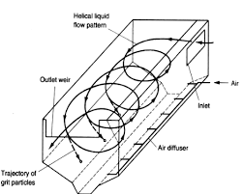

Figure 14 aerated grit chamber

**Design of horizontal flow aerated grit chamber**

Design criteria

Maximum flow of waste water

Detention time (t) is 30-90 sec (usually 60 sec)

Flow through velocity (V) is 0.2-0.4 m/s (usually 0.3 m/s)

Settling velocity (Vs) is 0.01-0.015 m/s for 0.15 mm diameter particle

Liquid depth 1-1.5 m

Length 3-25 m

Depth/Width (D/W) =1.5

The grit chamber is designed as follow Maximum flow (Q max) =160 m3/day Removed particle diameter = 0.15 mm Settling velocity (Vs) =0.013 m/s Flow through velocity (V) =0.3 m/s Liquid depth=1.5 m Depth/Width (D/W) =1.5

Assume: - in rectangular cross section Q max=160 m3/day

=0.0444 m3/s

Area =max flow/flow through velocity

=0.0444 m3/s /0.3 m/s

=0.148 m2

Area=d\*w

= 1.5 \*w\*w

=1.5w2  1.5w2 =0.148 m2

w=0.314 m Where:

d=1.5w. Q= flow rate

=1.5\*0.314 W=width of grit chamber

= 0.471 m D=depth of grit chamber Detention time (t)

t=d/Vs

=0.471/0.013

=36.23 sec Length determination (L) L=t\*V

=36.23 sec\*0.3 m/s

=10.86 m

Therefore, the dimension of aerated grit chamber is: L =10.86 m, D=0.471 m & W=0.314 m

### **5.10.4 Sedimentation tank**

Primary sedimentation takes place in the sedimentation tanks with the objective to remove readily settable solids and floating materials and thus reduce the suspended solids content. 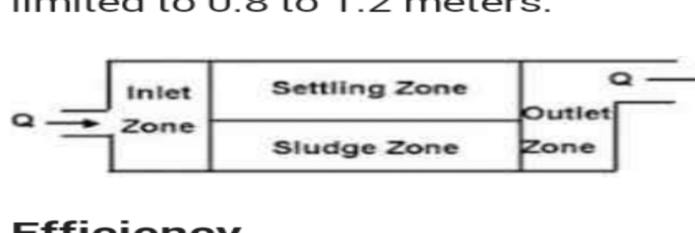

Figure 15 shows how sedimentation tank works

**Selection of sedimentation tank**

There are different types of sedimentation tanks. Such as rectangular tank, circular tank, hopper bottom tank and etc. Among these we choose rectangular sedimentation tank. Because

* It occupies less space and
* It is Economical to build than others (less cost).

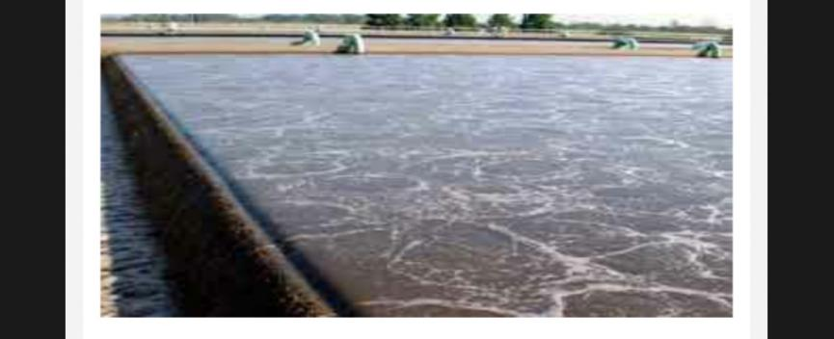

Figure 16 rectangular sedimentation tanks

**Design of rectangular sedimentation tank**

Design criteria

Over flow velocity of sedimentation tank is 12-18 m3/day/m2

Allowable flow through velocity is 0.005m/s

Detention period in the sedimentation tank is 4-8 hrs.

Length to breadth ratio of sedimentation tank is 4

The depth of tank should be 3-4.5 m

For rectangular sedimentation tank

Pick flow (Q) =130 m3/day

Depth of tank =3 m

L/B =4 m

Detention time (t) =4 hr.

Volume of tank=pick flow\*detention time

=130 m3/day\* 4 hr.\*1 day/24 hr.

=21.666 m3

Area of tank=volume of tank /depth of tank

=21.666 m3/3 m=7.222 m2

Area of tank =Length of tank (L) \*Breadth of tank (B)

=L\*B, but L= 4 B

=4B\*B=4B2

4B2 =7.22 m2

B=1.344 m

L=4\*B

=4\*1.344 m =5.376 m

Hence, over flow rate = pick flow area of tank

=130 m3/day/7.222 m2=18 m3/day/m

### **5.11 Result and Discussion**

The result of our project is described below.

Table 4 physio - chemical characterization

|  |  |  |  |  |  |
| --- | --- | --- | --- | --- | --- |
| Parameter | Syrup room | Washer room | CIP room | Production room | Total waste |
| Ph | 9.1 | 11.3 | 8.2 | 8.7 | 10.45 |
| Tds (pp) | 950 | 1300 | 1130 | 930 | 1070 |
| Tss(mg/l) | 56 | 60 | 41 | 32 | 45 |
| Temperature(oc) | 28 | 33 | 31.5 | 27 | 29.3 |

As noted in the table the PH, TDS and TSS of the waste water are far from the standard. By designing the above primary waste water treatment equipment’s and by using chemicals it can approach the standard values.

### **5.12 Conclusion and Recommendation**

### **5.12.1** **Conclusion**

The waste water characterize its physical and chemical parameters.by measuring temperature (10.45), TDS (1070 ppm), TSS 45(mg/l), turbidity. The waste comes from caustic soda, activated carbon, chlorine, lime, hyflu etc. use on the plant.

Large volume of waste water generated from the plant in each room is collected in a holding tank, and passes through a series of treatment stages before being discharge to the environment to decrease the effect on the aquatic life .In the first stage preliminary treatment, with the help of coarse screen and horizontal flow aerated grit chamber solid particles in suspension will be captured. Rectangular sedimentation tank is used in primary treatment for the removal and stabilization of settled solid after completed primary stage. The treated water can be used for gardening, cleaning and other purposes.

### **5.12.2 Recommendation**

The company access several instruments like flow rate, BOD, COD and TSS measuring devices and water jar to do best characterization of waste water.

Recommend to be the company consider the characterization and design of waste water treatment project which have presented in this study as it is cost effective and efficient. This will contribute to the safe being of the environment and help the company to cut on its cost through saving and contribute to improve its profitability.

The benefit of this project is for management, knowing the amount and property of wastewater generation and protection of our environment from hazards.

# CHAPTER SIX

## **6. Overall benefits of internship**

The overall benefits of the internship are not limited to the practical skill only but also include the following advantages:-

From this internship program, I have got a good chance to improve our practical skill highly. I can develop our skill in different circumstance which is mostly related to courses that I have taken in campus, especially heat transfer, mass transfer, basic environmental engineering, process industry, mechanical unit operation, analytical chemistry, process control I can see how to measure quality of the product, temperature, pressure, co2 volume, terrible acidity, alkalinity of water and hardness of water. The internship has so many benefits. It improves an awareness of the theoretical knowledge in to practical knowledge. Internship practice was very good in terms developing strength of real time engineering problem solving, gaining working knowledge and beside we learn how to plan that we will face for the future.

### **6.1 Main benefits of internship**

The experiences we gained during this internship program are categorized as;

* Practical skills
* Theoretical knowledge
* Inter-personal communication skills
* Team playing skills
* Leadership skills
* Work ethics & related issues, and finally
* Entrepreneurship skills

### **6.1.1 Practical Skills**

During this internship period, I have advanced our practical skills regarding the production, performance, process parameters and the machines that perform many works and gained new, different, and interesting knowledge about soft drinks. Some of the practical skills are;

* Chemical preparation
* Solving machine problems
* Observing and controlling quality of the product
* The way of treating water, and
* How to check the pH variations in chemicals

### **6.1.2 Theoretical Knowledge**

Theoretical knowledge is the base for all practical knowledge. It creates awareness and understanding about the practical aspects. Thus, I tried to relate each practical observation and experiences I get form the internship with the theoretical knowledge we get from class. This helped us in developing the theoretical knowledge and makes our previous knowledge practically supported.

### **6.1.3 Improving Communication Skills**

This one is the most common and important skill gained during our internship period. It helps a person to interact with others in a better and pleasant manner. It is an art to present one’s views, thoughts, and ideas to the listener.

It helped us in composing our project by asking question & info from the employees who guided us in the best possible way. Our interactions and dealings with the workers made our social interaction easy.

* It improves our speaking and listening skills
* We were motivated by the speech of the chemist that it led us to discover different problems and come up with solutions to them
* It helps in building self-confidence by discussing ideas with section head & other personnel

### **6.1.4 In terms of improving team playing skills**

As a team member, someone contributes a lot in many ways. There by, this improves every  
individual’s commutative knowledge of solving the existing problem. Being a team player, everyone can improve the following

* Ability to identify problem(s)
* Choosing the most appropriate method to solve the existing problem(s)
* How to ask questions without hesitation
* Respecting other’s opinions, and
* Helping others

### **6.1.5 Improving Leadership Skills**

Internship made us smart in managing our expenses regarding the project, how to become better sales person or how to manage a team. Learning these skills can really help in creating better individuals & better team. These items will help everyone developing their skills as a leader;

* Understanding group needs and characteristics
* Representing the group
* Knowing and understanding grouped resources
* Planning for the feature

### **6.1.6 In terms of understanding work ethics**

Work ethics involve the following characteristics

* Honesty
* Reliability
* Cooperating with collogues
* Punctuality
* Working independently
* Taking responsibility
* Creating goals
* Effective Communication
* Managing time effectively
* Being prepared to do everything for the team

### **6.1.7 In terms of Entrepreneurship skills**

Internship is an important tool for gaining experience and learning about one’s preferences and interests. Perhaps most importantly, the experience obtained has a great importance up on our life to choose and plan each of our future activity. Being an intern can build an individual knowledgeable in;

* Moral & Ethics
* Selecting effective way of doing work
* Increasing work efficiency
* Creative mind; solving problems of the company
* Extend different projects up on existing problem concerning the company.

# CHAPTER SEVEN

## **7. Conclusion and Recommendation**

**7.1Conclusion** this internship program is the best program for engineering students. Because I know what it put in our life? So we can say that it is the time students focus challenges. This helps that the students learn from challenges. The following things are negotiable for chemical engineer:

• Being practically knowledgeable

• Being confidential in theoretical knowledge

• Team work ability

• Creativity and problem solving ability etc…

The purpose of this intern ship program was to introduce students with working condition and mostly it helps students to grasp knowledge and practicing the theory which they have been learning. Some benefits I gained from the intern ship program are:-

• It Helps to improve theoretical knowledge and build our confidence • Team playing skill • Leadership skill • Work ethics •Entrepreneurship skill.

And also to gain professional contacts for searching jopes in the future

### **7.2 Recommendation**

I understand this internship program has mutual benefit for the student and the hosting company in many ways. So, I want to recommend for both the company (MOHA soft drinks Company) and our university in order to enable this internship program to be provided continuously for engineering students. I recommend that for future development an overload protection system, has not waste water treatment in the company. And the machine is very old then energy loss and product loss, so heat recovery necessary. And also the factory is in paisa. More dense people live around, they affect by the waste of unwanted gas and waste water discharge.

# References

*1. Water and waste water management in the soft drink industry (edition 2)*

*2. Reduction of the environmental impact of soft drink manufacturing plant (by yaseer ally) BSC Applied Chemistry August 2015 university of KwaZulu-Natal, Durban.*

*3. PepsiCo, (2005). Quality manual PepsiCo international manufacturing processing Vol-1 700 Anderson Hill Road, NY.*

*4. PepsiCo, (2005). Quality manual PepsiCo international Analytical methods Vol-2 700 Anderson Hill Road, NY.*

*5. PepsiCo, (2005). Quality manual PepsiCo international standards and specifications and operational practice Vol-3 and Vol -4 700 Anderson Hill Road, NY.*

*6. Google, environmental Applied Chemistry course mat*

*7. Fatima Hussein Abdi Ali Research, Iraq, 2011.*

*8. United States environmental protection agency*

*9. Komal Mehta Ph.D. thesis*

*10. Almukhtar, R. S. 2012. Water recycling/reuse in factories case study soft drink Factory. 10. Engineering and Technology Journal, 30(1):1-14*

# Appendix

1 day=24hr x=mass fraction of the component

1mi=60se q=flow rat

1hr=60mi L=length

h=head loss

B=breadth of tanks